|  |
| --- |
| This first page is information for staff – please delete this page before sharing the Module Handbook with your students - thank you! |

# Module Handbook Template

The information below needs to appear in all module handbooks. The Module Handbook needs to be available to students at the beginning of their studies on each module. Thus, the Module Handbook should be ready before the module starts and should normally **not** be amended during the module. The assessment section must not be changed during the running of the module. **All** sections should be completed, unless they do not apply to your module, e.g., PSRB requirements. You may also want to add specific information, which is important to your module, but is not listed below.

**One** module handbook needs to be completed for **each** iteration of the module. For example, if the module is delivered in semester 1 of 2025/26, then again in semester 2 of 2025/26, two module handbooks are needed (as they will have different assessment deadlines). Similarly, if the module is delivered at Canterbury but also at a partner college, please make two separate module handbooks to reflect the specificities of the delivery of each cohort. You can copy and paste the identical information, but please adapt any location specific information.

The handbook should cover all the essential information that students are entitled to know at the start of a module. The handbook will be published by module leader/course administrator under “Module Information” on each module Blackboard. Please do **not** duplicate sections of the Module Handbook elsewhere on Blackboard, to help avoid problems with version control if something does need to be amended.

Several sections of the handbook should be copied directly from the course approval documents for the course of which your module is a part. These are: aims, learning outcomes, type, and weighting of assessments. For other sections, please write the handbook for your students, keeping language clear.

This handbook should include details of further learning and teaching resources that will be available on Blackboard and elsewhere, for example, additional learning material for each session, ReCap recordings, assessment briefs or guidance, work placement handbook, etc.

When filling in the template, an indicative example of how you could complete the section is often given, or you can choose from a variety of options: **please delete the example /non-applicable options and any guidance text and add your own answer**.

Some elements are pre-written for you, as we feel it is important to guide students to other documents they should refer to for further information. Please do not amend these pre-filled elements.

|  |
| --- |
| **Module Handbook for [insert title of module]**  **Academic Year 2025/26** |

This document is presented in 12pt Arial font on an off-white background to improve accessibility in line with [2023 British Dyslexia Association guidelines](https://eur01.safelinks.protection.outlook.com/?url=https%3A%2F%2Fcdn.bdadyslexia.org.uk%2Fuploads%2Fdocuments%2FAdvice%2Fstyle-guide%2FBDA-Style-Guide-2023.pdf%3Fv%3D1680514568&data=05%7C02%7Cclaire.loffman%40canterbury.ac.uk%7Cc255c57f0324443f994308dd30c17660%7C0320b2da22dd4dab8c216e644ba14f13%7C0%7C0%7C638720329669264703%7CUnknown%7CTWFpbGZsb3d8eyJFbXB0eU1hcGkiOnRydWUsIlYiOiIwLjAuMDAwMCIsIlAiOiJXaW4zMiIsIkFOIjoiTWFpbCIsIldUIjoyfQ%3D%3D%7C0%7C%7C%7C&sdata=FvP2N3MAcfrwHR2xs2XBBDTKhM%2FnbgvPd%2BVgUKiSVBU%3D&reserved=0). If you – the student –require a different background colour, please do change by following the [Microsoft guide on background colour](https://eur01.safelinks.protection.outlook.com/?url=https%3A%2F%2Fsupport.microsoft.com%2Fen-gb%2Foffice%2Fadd-change-or-delete-the-background-color-in-word-db481e61-7af6-4063-bbcd-b276054a5515%23%3A~%3Atext%3DSelect%2520No%2520Color.-%2CChange%2520the%2520background%2520color%2Coptions%2520in%2520the%2520Color%2520box.&data=05%7C02%7Cclaire.loffman%40canterbury.ac.uk%7Cc255c57f0324443f994308dd30c17660%7C0320b2da22dd4dab8c216e644ba14f13%7C0%7C0%7C638720329669283629%7CUnknown%7CTWFpbGZsb3d8eyJFbXB0eU1hcGkiOnRydWUsIlYiOiIwLjAuMDAwMCIsIlAiOiJXaW4zMiIsIkFOIjoiTWFpbCIsIldUIjoyfQ%3D%3D%7C0%7C%7C%7C&sdata=Uyu1u7i7qXZK%2BHJVixKUssJt4Y%2FxuRKrOK7yII%2BlxGg%3D&reserved=0). Please note you can download an [alternative version of the handbook](https://eur01.safelinks.protection.outlook.com/?url=https%3A%2F%2Fwww.canterbury.ac.uk%2Fasset-library%2FGuides%2FLearning-Platform-Suite%2FAlly%2FBlackboard-Ally-1-2-3.pdf&data=05%7C02%7Cclaire.loffman%40canterbury.ac.uk%7Cc255c57f0324443f994308dd30c17660%7C0320b2da22dd4dab8c216e644ba14f13%7C0%7C0%7C638720329669303682%7CUnknown%7CTWFpbGZsb3d8eyJFbXB0eU1hcGkiOnRydWUsIlYiOiIwLjAuMDAwMCIsIlAiOiJXaW4zMiIsIkFOIjoiTWFpbCIsIldUIjoyfQ%3D%3D%7C0%7C%7C%7C&sdata=KQk5%2FtNoBEMAoL7BbZAFTmz%2B8JfPL14CNtVHrKJjQOE%3D&reserved=0) (including audio, Braille or HTML for enhanced viewing on mobile devices) from your course Blackboard.

**Module code:**

**Level of study:** choose from 0/4/5/6/7/8

**Number of credits:** (e.g. 15, 20, 30 credits)

**Course/s the module belongs to:** if several courses, state them all

**School:** insert the name of the School that the module belongs to for Quality Assurance reporting, even if the module is used by several Schools

**Semester/Trimester of delivery:** e.g., Semester 2

**Start date of the module:** e.g., September 2025

**Location of study:** add relevant campus, partner college campus or online (e.g., Canterbury, Medway, LSEC Bromley)

**Study hours for the module:** (usually 200 overall for a 20-credit module and 300 overall for a 30-credit module) Divide into:

* **Number of contact hours and pattern of delivery:** as agreed at the course approval event, this is the number of taught sessions and an indication of whether the pattern as regards face-to-face live teaching, online live teaching, includes hours for staff-led field trips, etc.
* **Number of guided hours:** this would include asynchronous digital activities as part of structured learning, e.g. reading, watching set videos, listening to set audio work, completing online quizzes or forum posts as set by the teaching team to prepare for sessions or consolidate session work
* **Number of placement hours:** where relevant
* **Number of independent study hours:** to be completed with no direct academic contact; this is an indication of what the additional personal input of each student should be per module to successfully complete the wider research and assessments necessary to succeed on the module.

**Professional accreditation status and requirements:** if applicable, if not, remove this section

**Module leader name:**

**Module leader contact details:**  add full name, email, phone, room number

**Other teaching staff with contact details:**

**How to access tutorials and other module support** e.g., list the office hours of teaching staff, or where information about module support is available

**Who is the module for?** e.g. “This module is a core module for first year students on the BA (Hons) History, and an optional module for <insert relevant route information>”

**Brief module summary:** Please include some headline information about the module; if the course was accredited prior to 2025 you may also include module aims here.

**Module learning outcomes** taken from approved module descriptor/specification

**Overview of learning and teaching activities on the module:** adapted from the module descriptor/specification, this section explains what is done for each category of class (lecture, seminar, workshop, lab, rehearsal, field trip, placement etc.) in broad terms. It must be module specific. If specific activities have a cost or specific requirements (e.g., field trips, specific equipment, etc), this should have been highlighted to students in the course handbook in addition to here. Please indicate whether the non-standard activities are optional or mandatory and, if optional, what any extra costs are likely to be.

**Equipment you need to bring to class** e.g., specific clothing, equipment. This should be taken from course information where it would have already been highlighted.

**Indicative schedule of delivery**: one line on what will be covered in each session; do adapt depending on whether the module is delivered weekly, in blocks or other pattern of delivery. The number of weeks should correspond to the Academic Calendar your module is aligned with. Please highlight dates for Academic Development Week and Personal Development Week and deadlines for assessments. Do incorporate here if field trips/visits are part of the module. Please adapt the table below to suit your needs

| **Session** | **Indicative Content** | **Independent Study Activities** |
| --- | --- | --- |
| 1 (insert date or week) |  |  |
| 2 |  |  |
| 3 |  |  |
| .. |  |  |
| .. |  |  |
| .. |  |  |
| 15 |  |  |

**Guidance on how to use independent study time:** e.g., “complete the set reading and answer the questions within a Blackboard discussion”

**Referencing system:** If the same system is used at course level, refer to the Student Course Handbook where this would have been noted.

**Assessments:** taken from approved module descriptor for columns 1, 2 and 5

| Summative assessment  Type  (What the assessment will be called on SITS/e:Vision and on Turnitin, e.g. “Coursework 1”, “Groupwork”, “Practical”, “Examination”) | % weighting | Deadline for submission of work and where assignment should be submitted  (e.g., Turnitin, PebblePad, Blackboard, in class). If the assessment is an exam and Registry Services have not informed you of the date of the exam, please state the period when it will be held, e.g. “w/c. 11 or 18th May 2026, exact day TBC”. State that all work submitted via Turnitin has a 2pm deadline) | Date for return of mark/grade and feedback and where they will be returned  (This is 15 working days after the deadline for submission, with a few exceptions. For place of return, it can be Turnitin, in class, etc) | Minimum pass mark for assessment task(s)  (Only for courses with special regs where some assessments need a pass mark to pass the module) |
| --- | --- | --- | --- | --- |
| **1.** | **%** |  |  | **e.g., 40%** |
| **2.** | **%** |  |  |  |

It is important that you meet your assessment deadline to help manage your workload and ensure your timely progression to your next level of study. However, we understand that in exceptional cases you may be unable to submit your work on time or do well in your exams due to unexpected events which are short-term in nature and beyond your control. Find out more about what to do in situations such as these [here](https://www.canterbury.ac.uk/our-students/ug-current/academic-services/assessments/extenuating-circumstances).

A coursework extension or a chance to re-take your exam is not an automatic right; to ensure fairness and transparency, exceptional circumstances requests will only be approved if they meet the criteria, are submitted on time and - where relevant - include appropriate professional evidence.

**Assessment brief/s:**

In this section, please add your assessment briefs for each summative assessment, which should contain the information below:

* Information about the nature of each summative assessment task, and instructions on how to complete it
* Formative activities: list activities that prepare students for their summative work, and deadlines for submission if applicable
* Assessment criteria for all the assessments: if provided in the student course handbook at course level, refer to the handbook. If each assessment has specific criteria, include each set of criteria
* Where additional assessment guidance/brief can be found: if not in this handbook (e.g., “Assessment FAQs, exemplars of mocks papers and model answers can be found in the ‘Assessment’ folder on the Blackboard site for the module”)
* If the assessment(s) are to be marked anonymously, see the [Exams and Coursework procedures](https://www.canterbury.ac.uk/our-students/ug-current/academic-services/assessments/exams-and-coursework-procedures) and if not anonymous, please say why not.

**Generative Artificial Intelligence (GenAI) and Assessments**

Before approaching any assessment you should read the student guidance on the use of GenAI: [Welcome to your generative AI guidance](https://www.canterbury.ac.uk/our-students/ug-current/libraries-and-study-support/study-support/welcome-to-your-generative-ai-guidance)

This will ensure you are aware of the ethical, legal and learning aspects of using GenAI for your studies.

Each module’s assessments will require a different approach to the use of Generative Artificial Intelligence (GenAI). Your Module Lead has evaluated this module’s assessment(s) using the Artificial Intelligence Assessment Scale (AIAS).

You can learn more about the AIAS at [aiassessmentscale.com.](https://aiassessmentscale.com/)

If you would like to understand more about how CCCU’s staff understand the use of GenAI in your learning, you can read the [Staff Guidance](https://www.canterbury.ac.uk/learning-and-teaching-enhancement/resources-for-academics/ai-staff-guidance.aspx).

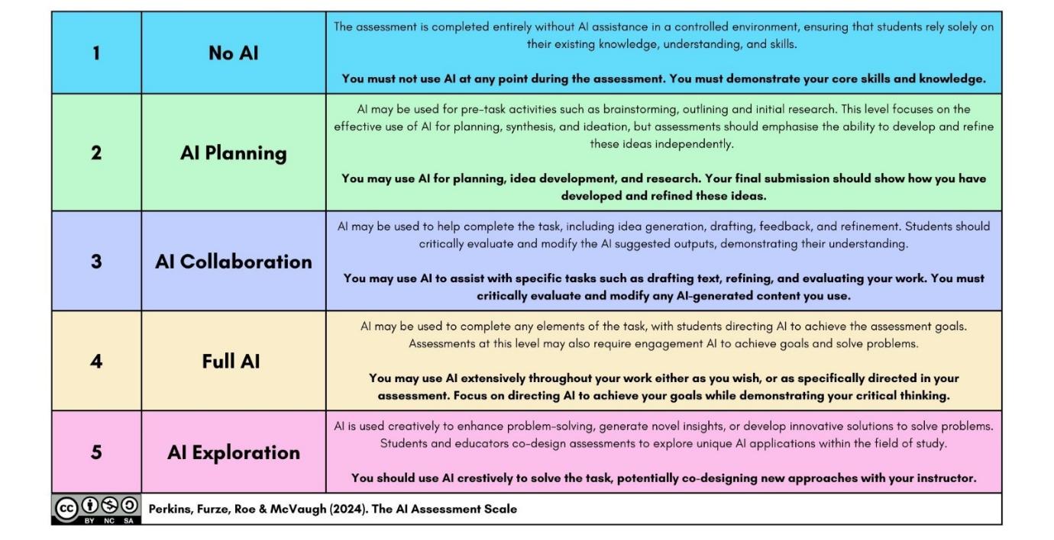

**Your Module Lead has evaluated this module’s assessments as requiring the following level of interaction with GenAI:**

Assessment 1:

Assessment 2:

**At CCCU all assessments require a declaration regarding the level of GenAI use.**

Under CCCU’s Academic Integrity Policy unacknowledged inclusion of GenAI is considered academic misconduct. See the [Academic Integrity and Misconduct](https://www.canterbury.ac.uk/our-students/ug-current/academic-services/assessments/plagiarism) webpages for more information.

Please select the most appropriate statement from the choice below and insert it at the start of your work:

1. No GenAI was used in the preparation, planning or creation of this work. [AIAS Level 1]
2. I acknowledge the use of outputs from [insert the name of generative AI tool(s) used] in the learning, preparation, planning or proofreading of this work. [AIAS Level 2]
3. I acknowledge collaboration with [insert the name of generative AI tool(s) used] in this work, and the inclusion of outputs in modified form. [AIAS Level 3]
4. I acknowledge [insert the name of generative AI tool(s) used] as partner(s) in the creation of this work. [AIAS Levels 4 & 5]

**Referencing GenAI**

If your assessment is rated at levels 2, 3 or 4, **you are required to reference where you have used GenAI outputs in the body of your work**. For guidance on how to reference GenAI in your work see Cite Them Right 13th Edn, or later. You can use the textbook or visit the [Cite Them Right](https://www.citethemrightonline.com/) website – both are accessible via [LibrarySearch](https://ulms.ent.sirsidynix.net.uk/client/en_GB/CCCU) (for the web version, login using your CCCU email).

You can speak to your module tutor, module lead, subject Librarian or Learning Developer [job titles subject to change] for more guidance on the use of GenAI in your learning and assessment.

**Reassessment information:** the text below is for **all** handbooks

Some students may not pass an assessment first time and will be invited to take reassessment for the module, following a decision from a Board of Examiners. Do check the [Your Guide to Assessment and Award Processes](https://www.canterbury.ac.uk/our-students/online-documents/your-student-university-guides) and seek advice from your Personal Academic Tutor if this is the case for you. Your module team will offer support in preparation for your reassessment.

In this case, the nature of the reassessment will be:

| **Original assessment**  This should be identical to the assessment table column 1 | **Reassessment type**  Usually, the same type of assessment and brief, but exam questions may vary | **Deadline for submission of reassessment, and where it should be submitted**  If no exact date is known, provide a week e.g., w/c 12 July 2026 |
| --- | --- | --- |
|  |  |  |
|  |  |  |

This handbook should be read in conjunction with other sources:

* Student Course Handbook: for course academic information applying to all modules
* [Current Student Webpages](https://www.canterbury.ac.uk/students/current-students/current-students.aspx): for generic student experience information

**Learning Materials/Resources:** From autumn 2025, module resource lists will be provided through TalisAspire (for new courses on the academic framework). Module leads are asked to ensure that their TalisAspire lists are updated and correct (please contact library services if you require help), and the link to the list is shared in your module handbook as well as on your module Blackboard.

**Date and validity** e.g., July 2025, valid for academic year 2025/2026